**Ideation Phase**

**Define the Problem Statements**

|  |  |
| --- | --- |
| Date | 16 June 2025 |
| Team ID | LTVIP2025TMID30062 |
| Project Name | Sustainable Smart City Assistant Using IBM Granite LLM |
| Maximum Marks | 2 Marks |

**Customer Problem Statement Template:**

Create a problem statement to understand your customer's point of view. The Customer Problem Statement template helps you focus on what matters to create experiences people will love.

A well-articulated customer problem statement allows you and your team to find the ideal solution for the challenges your customers face. Throughout the process, you’ll also be able to empathize with your customers, which helps you better understand how they perceive your product or service.

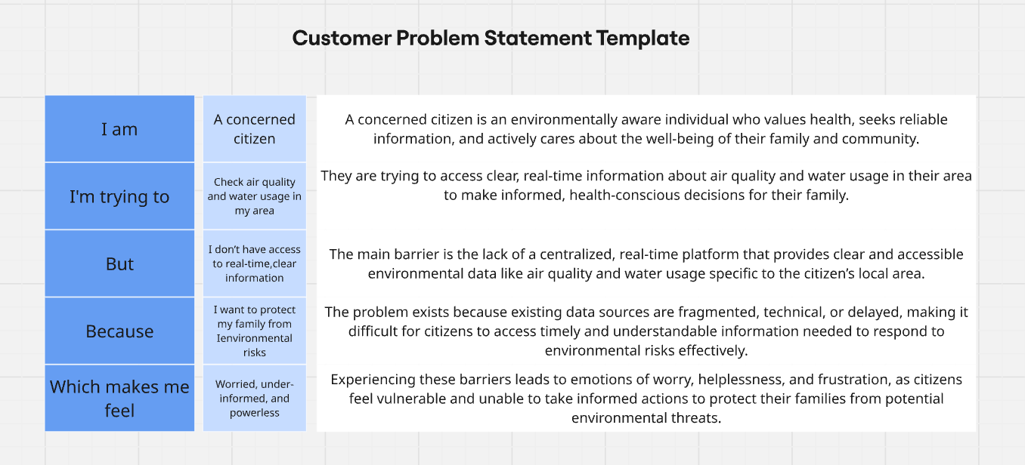

Reference: <https://miro.com/templates/customer-problem-statement/>

|  |  |  |  |  |  |
| --- | --- | --- | --- | --- | --- |
| **Problem Statement (PS)** | **I am (Customer)** | **I’m trying to** | **But** | **Because** | **Which makes me feel** |
| **PS-1** | A city administrator | Monitor city KPIs and respond to anomalies quickly | I don’t have a unified system | Data is scattered and not actionable in real-time | Frustrated and unable to make timely decisions |
| **PS-2** | A city resident | Understand policies and give feedback | The documents are too complex | They are written in legal language and too long | Ignored and disconnected from city governance |
| **PS-3** | An environmental officer | Promote sustainable practices among citizens | I can’t reach them effectively | There is no smart platform to provide daily eco-advice | Limited in impact and reach |
| **PS-4** | A data analyst in the city council | Analyze service performance trends | There is no forecasting or anomaly alert system | Manual analysis takes too long | Overwhelmed and reactive instead of proactive |